CUSTOMER CHURN ANALYSIS REPORT

ACS Work Integrated Learning (WIL) Project

PREPARED BY
Winfred Wambui Njaramba – Business Analyst

PROJECT TEAM
Mmaduabuchi Nnaneme Omeje - Data Engineer
Lawi Kiplagat Biwott - Project Manager
Liuyang Zhang - Data Analyst (Clustering)
Meng Shao - Data Analyst (Predictive Modelling)

Submission Date: March 2026

ACKNOWLEDGEMENT
We respectfully acknowledge the Traditional Custodians of the land on which this project was developed and pay our respects to Elders past and present. We recognise the enduring connection of Aboriginal and Torres Strait Islander peoples to Country and their ongoing contributions to the community.

Table of Contents
1. INTRODUCTION 1
2. METHODOLOGY 1
2.1. Data Preparation 1
2.2. Customer Segmentation 1
2.3. Predictive Modelling 2
3. SUMMARY KEY FINDINGS 2
3.1. High-Risk Customer Segment Identified 2
3.2. Strong Classification Performance 3
3.3. Most churners can be identified before cancellation occurs. 4
3.4. Reliable Prediction Across Risk Levels 5
3.5. Threshold Optimisation Increased Churn Detection 6
4. IDENTIFICATION OF FACTORS CONTRIBUTING TO CHURN AND RETENTION 6
4.1. Contract Type 6
4.2. Customer Tenure 7
4.3. Monthly Charges 8
4.4. Customer Segments 8
5. RECOMMENDATIONS FOR TARGETED RETENTION STRATEGIES. 8
5.1. Implement Predictive Churn Monitoring 8
5.2. Apply Targeted Retention Management for Month-to-Month Contract Customers 9
5.3. Introduce Early-Tenure Retention Monitoring 9
5.4. Protect High-Value Customers Through Billing and Value Alignment Review 9
5.5. Establish Retention Monitoring and Continuous Improvement Process 10
6. LIMITATIONS AND PROPOSED SOLUTIONS 10
6.1. Limited Availability of Customer Behaviour and Experience Data 10
6.2. Class Imbalance Between Churn and Non-Churn Customers 10
6.3. Trade-Off Between Recall and Precision 11
6.4. Model Dependence on Historical Customer Behaviour 11
6.5. Lack of Live Operational Deployment During the Project 11
6.6. Project Time and Scope Constraints 11
APPENDICES 12

INTRODUCTION
This report presents the outcomes of a customer churn prediction analysis conducted on a telecommunications dataset comprising 7,043 customer records. The objective of the project was to identify customers at risk of discontinuing their services, understand the key contractual and service-related factors associated with churn, and support the business with data driven retention strategies.
The dataset included customer demographics, contract type, tenure, subscribed services, monthly charges, total charges, and a churn indicator showing whether the customer had left or remained. Initial data validation confirmed that the dataset was complete, with no missing or inconsistent values, allowing the modelling process to proceed without data imputation. Categorical variables were converted into numerical format to support machine learning analysis, and numerical variables were standardised to ensure consistency across all input features. A stratified train and test split was applied to maintain the churn proportion of approximately 26.5% in both datasets, ensuring reliable and unbiased model evaluation.
Following data preparation, customer segmentation was conducted to identify groups with different churn behaviours. This was followed by the development of a deep Artificial Neural Network model, which was trained to estimate churn probability for each customer and support early identification of high-risk customers for retention planning.

METHODOLOGY
The analysis was conducted in three main stages: data preparation, customer segmentation, and predictive modelling.

Data Preparation
The dataset was first reviewed to confirm completeness and suitability for modelling. No missing or inconsistent values were identified. Categorical variables such as contract type and internet service were converted into numerical format to allow machine learning processing. Numerical variables including tenure, monthly charges, and total charges were standardised to ensure all features were on a consistent scale. The dataset was then divided into training and testing sets using a stratified split to maintain the original churn distribution and ensure reliable model evaluation.

Customer Segmentation
Customer segmentation was performed using K Means clustering to group customers based on similarities in tenure, contract type, service subscription, and billing characteristics. The optimal number of clusters was determined using the elbow method. Each cluster was analysed to identify differences in churn rates and customer behaviour, allowing high risk customer groups to be identified.

Predictive Modelling
A deep Artificial Neural Network was developed to predict customer churn. The model was trained using the prepared training dataset and validated to ensure performance was stable and generalisable. Feature scaling was applied prior to training to improve model performance. The model produced a churn probability score for each customer, which was then used to classify customers as churn or non-churn based on an optimised threshold.
Model performance was evaluated using Accuracy, Precision, Recall, F1 Score, ROC AUC, and Precision Recall AUC. A confusion matrix was also used to assess the number of correctly and incorrectly classified customers.

SUMMARY KEY FINDINGS

High-Risk Customer Segment Identified
Customer segmentation analysis was conducted to group customers based on similar service, contract, and billing characteristics. The analysis identified five distinct clusters, each showing different churn behaviour.
Table 1: Churn Behaviour
Cluster | Customer Profile | Churn Rate
Cluster 0 | Long-term contract loyal customers. | 23.14%
Cluster 1 | DSL customers on month-to-month contracts | 24.55%
Cluster 2 | Fibre internet customers on month-to-month contracts | 25.26%
Cluster 3 | Customers with no phone service | 23.14%
Cluster 4 | Senior customers with higher monthly charges | 41.62%

Cluster 4 recorded a churn rate of 41.62%, which is significantly higher than the overall churn rate of 26.5%. The results clearly show that churn is not evenly distributed across the customer base. Instead, it is concentrated within a specific high-risk group characterised by higher billing and customer profile differences.
This confirms that customer characteristics strongly influence churn behaviour and that segmentation provides a structured method for identifying high-risk customer groups. This means customers in this segment were 1.57 times more likely to churn than the average customer.
The results clearly show that churn is not evenly distributed across the customer base. Instead, it is concentrated within a specific high-risk group characterised by higher billing and customer profile differences.
Figure 1: Churn rate by clusters
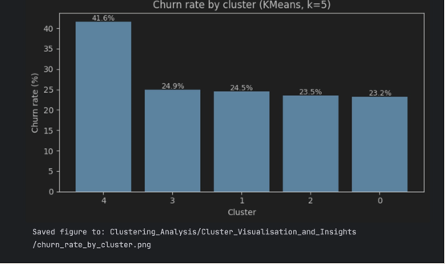

Strong Classification Performance
Figure 2: ROC Curve (test)
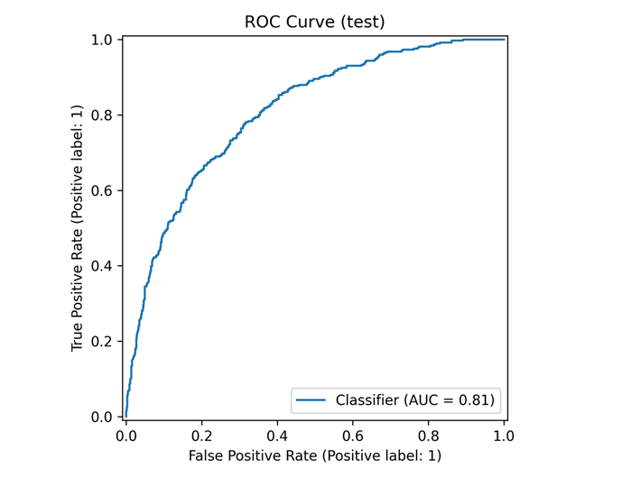
Figure 2: ROC Curve Showing Model Discrimination (AUC = 0.81)
The ANN model achieved a ROC AUC score of 0.81, demonstrating strong ability to distinguish between customers who churned and customers who remained.
An AUC of 0.81 means that when comparing a churned customer and a retained customer, the model correctly assigns a higher churn probability to the churned customer in 81 percent of cases. accurately separate high-risk customers from low-risk customers based on their churn probability.
The ROC curve shows consistently high true positive rates across different probability thresholds, confirming reliable classification performance. This confirms that the model successfully learned behavioural and contractual patterns associated with churn.

Most churners can be identified before cancellation occurs.
After threshold optimisation, the model achieved a recall of approximately 86%. In practical terms, this means that nearly nine out of every ten customers who would churn were flagged as high risk ahead of time. This outcome is particularly important because it enables proactive intervention. Detecting customers early allows retention teams to contact them before dissatisfaction results in cancellation.
Figure 3 – Confusion Matrix
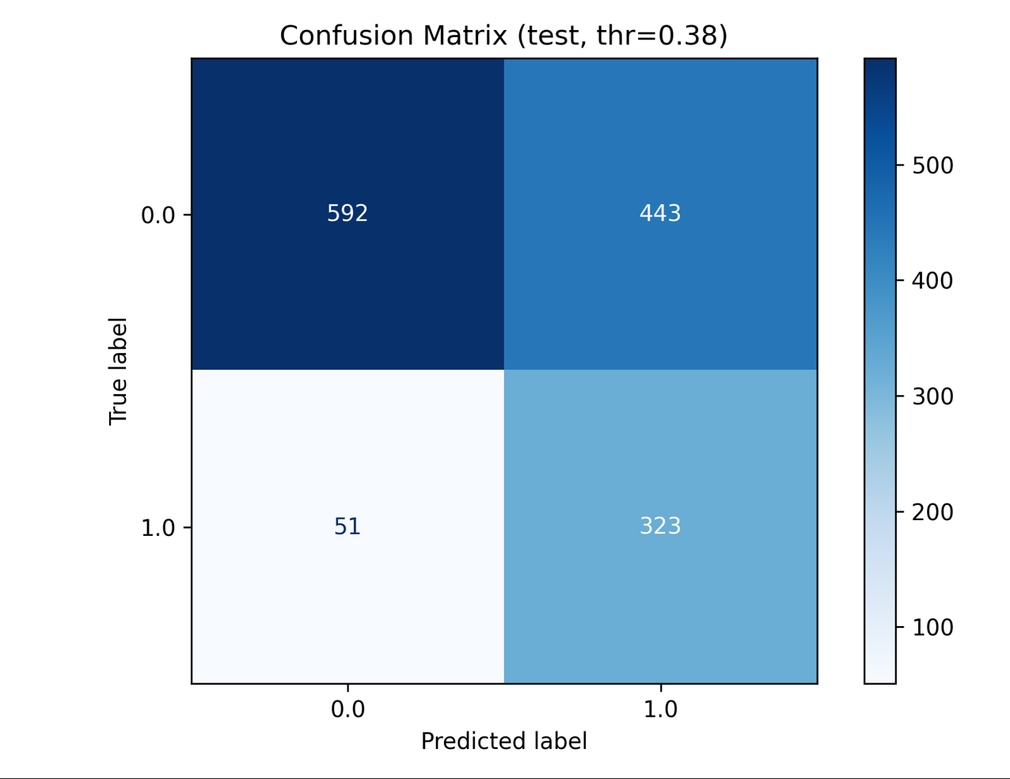
Figure 3: Confusion Matrix Showing Classification Outcomes.
The model was evaluated on 1,409 customers in the test dataset and produced the following results:
- 323 churn customers correctly identified
- 592 retained customers correctly identified
- 51 churn customers missed
- 443 retained customers flagged as churn risk
This resulted in a recall rate of 86.4%, meaning the model successfully identified more than 86 out of every 100 customers who churned.
Only 13.6% of churn customers were missed, confirming strong detection capability. This demonstrates that the ANN model can reliably detect customers at risk of churn before they leave.

Reliable Prediction Across Risk Levels
Figure 4 – Precision-Recall Curve (test)
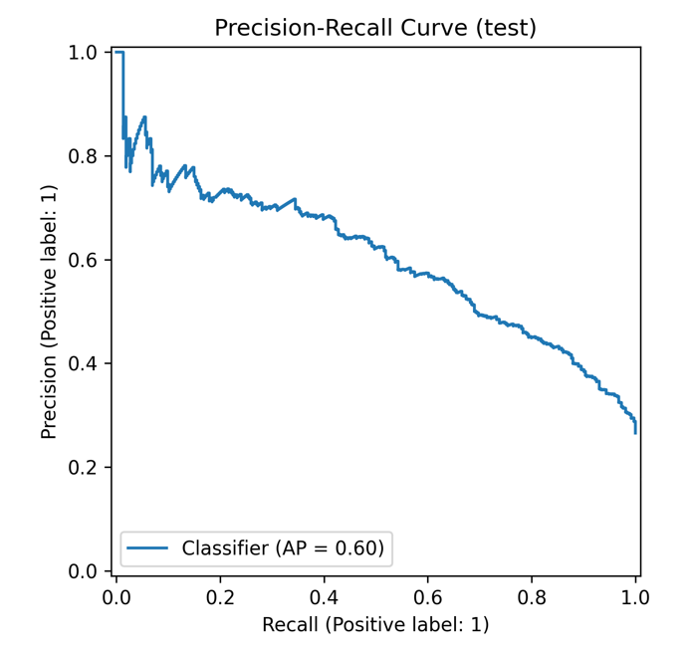
Figure 4: Precision-Recall Curve Showing ANN Model Performance (Average Precision = 0.60)
The model achieved a Precision-Recall AUC score of 0.60, confirming reliable churn prediction performance in an imbalanced dataset where churn represents 26.5% of customers.
The curve shows that the model maintains consistent predictive strength across different probability thresholds. As recall increases, precision gradually decreases, reflecting the expected trade-off between identifying more churn customers and increasing false positives. This confirms that the model provides meaningful churn prediction rather than random classification.

Threshold Optimisation Increased Churn Detection
The Artificial Neural Network assigns each customer a churn probability score between 0 and 1, representing the likelihood that the customer will discontinue their service. To convert this probability into a final classification, a threshold is applied. Customers with a predicted churn probability above the threshold are classified as churn risk, while those below the threshold are classified as retained.
Initially, the model used the default threshold of 0.50, meaning only customers with a predicted churn probability greater than 50% were classified as churn risk. At this threshold, the model achieved a churn detection rate (recall) of 75.4%, meaning approximately three out of every four churn customers were correctly identified.
Following threshold optimisation, the classification threshold was lowered to 0.38, allowing customers with a churn probability above 38% to be classified as churn risk. This adjustment increased the churn detection rate to 86.4%.
This improvement enabled the model to correctly identify 48 additional churn customers who would not have been detected using the default threshold. This finding confirms that selecting an appropriate threshold significantly improved the model’s ability to detect churn risk and enhanced its effectiveness in identifying customers likely to leave.

IDENTIFICATION OF FACTORS CONTRIBUTING TO CHURN AND RETENTION

Contract Type
Contract type was a major factor influencing customer churn. Customers on month-to-month contracts showed higher churn behaviour compared to customers on fixed-term contracts. The absence of long-term commitment allows customers greater flexibility to discontinue their service, making them more sensitive to pricing changes, service experience, or competing offers.
Figure 1: Churn by contract
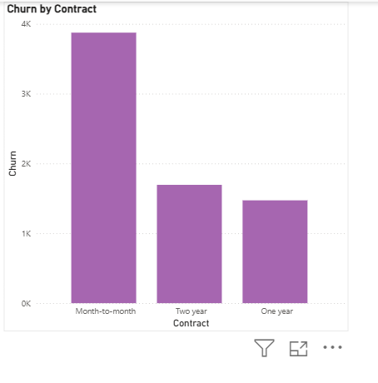
Figure1: Shows the month-to-month contractors are the highest churners
Customer segmentation showed that customer groups associated with flexible contract arrangements experienced higher churn levels compared to customers characterised by contract stability. In contrast, customers on longer-term contracts demonstrated stronger retention and more stable service continuity.
The ANN model’s strong churn detection performance confirms that contract type formed part of the predictive pattern used to identify customers at risk. This indicates that contract structure plays an important role in influencing whether customers remain or leave.

Customer Tenure
Customer tenure was another key factor influencing churn risk. Customers with shorter service duration were more likely to churn compared to customers with longer service relationships. This reflects the early stage of the customer lifecycle, where customers are still evaluating the service and are more likely to leave if their expectations are not fully met.
Customer segments associated with stronger retention demonstrated lower churn levels and were characterised by more established service relationships. In contrast, customers in higher-risk segments showed weaker relationship stability.
The ANN model successfully identified the majority of churn customers, confirming that tenure was an important characteristic influencing churn probability. This indicates that customer retention strengthens over time as the customer relationship becomes more established.

Monthly Charges
Monthly charges were strongly associated with churn behaviour. The customer segment with the highest churn rate of 41.62% was characterised by higher monthly charges, which was significantly above the overall churn rate of 26.5%.
This indicates that customers paying higher service costs were more likely to discontinue their service. Higher billing levels increase customer expectations of value, and when customers do not perceive sufficient benefit relative to cost, churn becomes more likely.
The ANN model’s predictive performance confirms that billing level was one of the factors influencing churn risk. Customers with higher monthly charges were more frequently classified as churn risk compared to lower-billing customers.

Customer Segments
Customer churn was not evenly distributed across the customer base but was concentrated within specific customer segments. Certain customer groups demonstrated significantly higher churn behaviour, while others showed stronger retention.
These differences reflect variations in customer characteristics such as contract structure, billing level, and relationship stability. The high-risk customer segment recorded substantially higher churn behaviour compared to other segments, confirming that customer profile plays an important role in retention outcomes.
The ANN model’s strong classification performance, including a ROC AUC score of 0.81, confirms that these segment differences were meaningful predictors of churn risk. This demonstrates that churn behaviour follows identifiable patterns linked to customer characteristics.

RECOMMENDATIONS FOR TARGETED RETENTION STRATEGIES.

Implement Predictive Churn Monitoring
The ANN model should be deployed as a recurring churn risk scoring process rather than a one-off analytical exercise. Each scoring cycle should generate a churn probability for every active customer and classify customers into risk categories based on the defined operating threshold. Because the threshold was optimised during model development to improve churn detection, the business should adopt this tuned threshold as the starting point for operational use, while retaining the flexibility to adjust it based on business capacity and retention priorities.

To implement this in practice, the model should be run on a regular basis, such as monthly, using updated customer data. The output should produce a prioritised list of high-risk customers ranked by churn probability. These customers should then be assigned to appropriate teams for review within defined timeframes. Retention outcomes should also be recorded, including whether flagged customers churned, remained, or changed behaviour. Creating a continuous retention cycle where predictive outputs directly inform business action and generate feedback to improve future retention decisions.

Apply Targeted Retention Management for Month-to-Month Contract Customers
Customers on month-to-month contracts represent a structurally higher churn risk because they are not bound by long-term agreements and can leave at any time. Instead of applying general retention efforts across all customers, the business should use ANN predictions to identify high-risk customers within this contract group and apply structured account review.
This involves filtering the high-risk customer list to identify those on month-to-month contracts and reviewing their account data to understand the likely cause of churn risk. This review should include recent billing changes, service usage trends, customer support history, and service plan adjustments. For example, if churn risk is associated with recent billing increases, this indicates pricing sensitivity. If the customer has repeated service issues, this indicates service quality concerns.

Introduce Early-Tenure Retention Monitoring
Customers with shorter tenure represent a critical churn period because the customer relationship is still developing, and expectations may not yet be fully met. The ANN model can identify newer customers who show characteristics similar to historical churn cases, allowing the business to intervene early.
Getting to identifying customers within their first 6 to 12 months of service and applying ANN churn scoring to prioritise monitoring. Customers classified as high risk should be reviewed to identify potential early disengagement indicators such as lower than expected service usage, billing concerns, or frequent service interactions. Reviewing these signals allows the business to identify service misalignment or dissatisfaction before the customer decides to leave.

Protect High-Value Customers Through Billing and Value Alignment Review
Customers with higher monthly charges were associated with higher churn risk and represent greater financial impact if lost. Retention strategies should therefore prioritise protecting these high-value customers.
Identifying customers with high monthly charges who are also classified as high churn risk by the ANN model. Their billing and service profile should then be reviewed to assess whether their service plan aligns with their actual usage and needs. For example, customers paying for higher-tier plans but using fewer services may perceive lower value, increasing churn likelihood. Ensuring billing structure aligns with service value improves customer satisfaction and reduces churn risk, while protecting revenue.

Establish Retention Monitoring and Continuous Improvement Process
To ensure long-term effectiveness, implement a structured monitoring process to evaluate retention outcomes and refine retention strategies over time. Because the ANN model prioritises identifying churn customers, some customers classified as high risk may not churn. Monitoring outcomes ensures retention actions remain efficient and aligned with business capacity.
By tracking key performance indicators such as churn rate among high-risk customers, retention success rate after intervention, and overall churn trends. If retention capacity is limited, the business can prioritise customers with the highest churn probability. If the goal is to reduce missed churn cases, the business can maintain the current threshold setting ensuring retention strategies remain aligned with business priorities and operational capability.

LIMITATIONS AND PROPOSED SOLUTIONS

Limited Availability of Customer Behaviour and Experience Data
The model was developed using available variables such as tenure, contract type, service subscriptions, and billing information. However, the dataset did not include behavioural and service experience variables such as customer complaints, service interruptions, network performance, or customer satisfaction indicators. These factors can directly influence customer decisions to leave but were not available for modelling.
Proposed Solution: Future model development should incorporate additional customer interaction and experience data from operational systems. This includes customer support records, complaint frequency, service quality metrics, and customer feedback data. Including these variables would improve the model’s ability to capture the full drivers of churn and increase prediction accuracy.

Class Imbalance Between Churn and Non-Churn Customers
The dataset contained approximately 26.5% churn customers and 73.5% retained customers. This imbalance reflects real-world customer distribution but creates modelling challenges, as the model has fewer examples of churn behaviour compared to retained customers.
Proposed Solution: As new customer data becomes available; the model should be retrained using updated datasets that include additional churn cases. This will allow the model to learn from more recent churn behaviour and improve classification accuracy. The business should also continue monitoring model performance and adjust the operating threshold based on retention capacity and business priorities.

Trade-Off Between Recall and Precision
The ANN model was optimised to prioritise recall in order to detect as many churn customers as possible. This approach improves churn detection but increases the number of false positives, where some customers are classified as churn risk but do not actually churn.
Proposed Solution: The business should use churn probability scores as a prioritisation tool rather than relying only on the classification outcome. Customers with the highest churn probability should be prioritised first. The threshold used to classify churn risk can also be adjusted depending on operational capacity, allowing the business to control the number of customers flagged for retention review.

Model Dependence on Historical Customer Behaviour
The ANN model was trained using historical customer data and learned patterns based on past churn behaviour. However, customer behaviour may change over time due to pricing changes, market competition, or service improvements. These changes may affect the model’s ability to accurately predict future churn if the model is not updated.
Proposed Solution: The model should be retrained periodically using updated customer data to ensure that it reflects current customer behaviour. Regular retraining, such as every 6 to 12 months, will allow the model to maintain predictive accuracy and remain aligned with changing business conditions.

Lack of Live Operational Deployment During the Project
The model was developed and validated within a controlled project environment and was not deployed into a live operational system during the project period. This means that the model’s performance in real-time business conditions has not yet been fully evaluated.
Proposed Solution: The business should integrate the ANN model into its analytics environment and establish a regular churn scoring process using live customer data. This will allow the model to support real-time churn monitoring and enable its use in operational retention decision-making.

Project Time and Scope Constraints
The project was completed within a defined academic timeframe, which limited the ability to test additional modelling approaches or conduct extended performance monitoring over time. Additional testing may identify opportunities to further improve prediction performance.
Proposed Solution: Future work should include testing alternative machine learning models and comparing their performance with the ANN model. Ongoing model evaluation will ensure the business continues using the most effective churn prediction approach.

APPENDICES
Jira Link:
https://lawi-kiplagat-biwott.atlassian.net/jira/software/projects/KAN/list
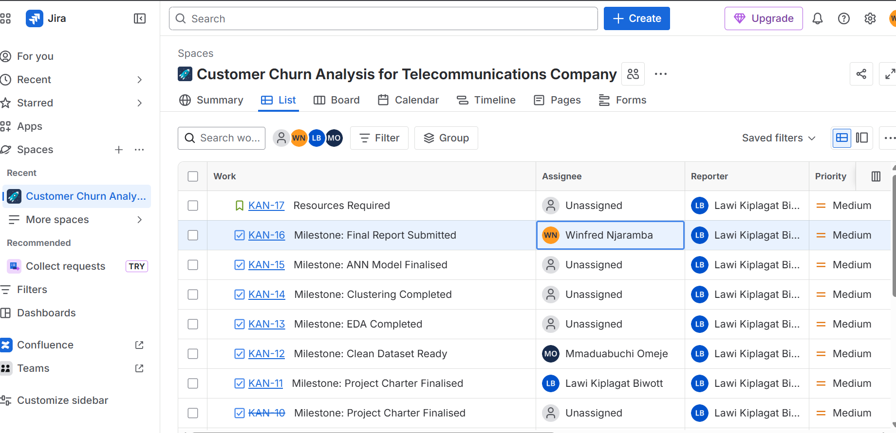
GitHub Link:
https://github.com/LawiKips/Customer-Churn-Analysis-for-Telecommunications-Company
